3. SYSTEM DESIGN AND ARCHITECTURE
a. System Architecture
The system architecture of the Santa Rita Automated Relief Assistance System (S.A.R.A.) illustrates how the different components of the system are organized and how they communicate with one another. The system follows a layered web-based structure composed of the Presentation Layer, Application Layer, Service/API Layer, and Data Layer, with separate components for hardware integration, external services, and authentication and authorization.
Users access the system through the web interface, while the application layer processes requests and applies the business rules of the system. The service or API layer handles data exchange between the interface and system processes, while the data layer stores the information required by the system. The architecture also integrates a USB RFID reader for beneficiary identification and external services for email and map-related functions.
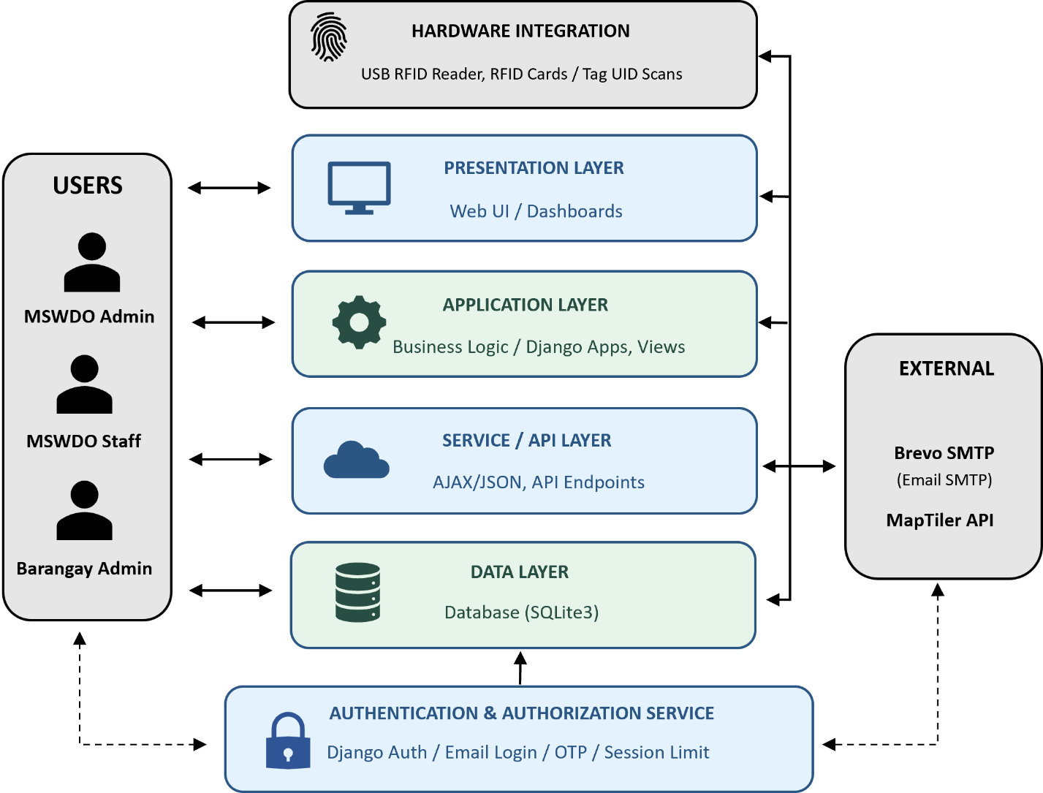
Figure 4.X. System Architecture of S.A.R.A.

1. Users
The system is accessed by three primary user roles: MSWDO Administrator, MSWDO Staff, and Barangay Administrator. Each role is provided with different access privileges based on their responsibilities. The MSWDO Administrator has municipal-wide administrative access, MSWDO Staff performs operational activities, while the Barangay Administrator has access limited to the assigned barangay and authorized functions.
2. Presentation Layer
The Presentation Layer serves as the interface between the users and the system. It contains the Web User Interface (Web UI) and dashboards through which users access the different modules of S.A.R.A.
This layer handles user interaction such as viewing dashboards, entering household information, managing records, creating and viewing schedules, processing claims, monitoring distributions, and generating reports. The system uses Django templates for its web interfaces, with JavaScript-supported interactions and Chart.js for analytics and dashboard visualizations.
3. Application Layer
The Application Layer contains the core business logic of S.A.R.A. and is implemented using Django 6.0. It processes requests received from the presentation layer and determines what actions should be performed based on the user's role, permissions, and system rules.
The layer is divided into several Django applications, including Accounts, Core, Households, Programs, Distribution, RFID, Monitoring, and Reports. These applications handle authentication, household profiling, aid-program management, eligibility checking, beneficiary selection, distribution scheduling, RFID claims, monitoring, analytics, and report generation.
4. Service/API Layer
The Service/API Layer provides communication between the application's user interface and specific system functions. It uses AJAX/JSON and API endpoints to retrieve and transmit data without requiring complete page reloads for certain operations.
Examples include dashboard analytics, demographic information, monthly claim data, live RFID claim monitoring, schedule status, and family-member information used during individual assistance processing.
5. Data Layer
The Data Layer is responsible for the persistent storage of the system's information. In the presented implementation, SQLite3 serves as the database used by the system.
The database stores information such as user accounts, barangays, households, family members, aid programs, assistance records, eligibility rules, distribution schedules, beneficiary lists, RFID records, claims, staff assignments, venues, and audit logs. The Django ORM is used by the application to create, retrieve, update, and manage the stored records.
6. Hardware Integration
S.A.R.A. integrates a USB RFID Reader for RFID card and tag UID scanning. The RFID reader provides a faster method of identifying beneficiaries during relief distribution. Once an RFID UID is scanned, the system checks the associated family or beneficiary information and applies the required eligibility, assignment, and distribution rules before recording the claim. The system also supports manual claim processing when an RFID card is unavailable.
7. External Services
The system communicates with external services to support selected functions.
Brevo SMTP is used as the email delivery service for sending authentication-related messages such as OTP codes.
MapTiler API is used for map-related functionality, including the visualization of household locations and flood-prone areas.
8. Authentication and Authorization Service
The Authentication and Authorization component protects the system from unauthorized access. S.A.R.A. uses Django authentication together with email-based login, OTP verification, session control, and role-based access control.
Users must successfully authenticate before accessing the system. After login, the system determines the user's assigned role and provides access only to functions permitted for that role. Additional controls include login rate limiting, OTP brute-force protection, session protection, password management, and CSRF protection.
9. Communication Between Components
The general communication process begins when a user interacts with the web interface. The request is passed to the Django application, where authentication and authorization are checked. The appropriate business logic is then executed, including validation, eligibility checking, beneficiary processing, or claim processing. The application communicates with the SQLite3 database when information needs to be stored or retrieved.
For selected dynamic functions, the presentation layer communicates with the Service/API Layer using AJAX and JSON. The system can also communicate with the USB RFID reader during claim processing and with external services such as Brevo SMTP and MapTiler when their respective functions are required.
b. System Architecture Pattern
The Santa Rita Automated Relief Assistance System (S.A.R.A.) adopts a Three-Tier Layered Architecture. This architecture separates the system into different layers based on their responsibilities, allowing the presentation, application processing, and data storage components to operate in an organized manner.
The first layer is the Presentation Layer, which provides the web interface and dashboards used by the MSWDO Administrator, MSWDO Staff, and Barangay Administrator. It is responsible for displaying information and accepting user inputs.
The second layer is the Application Layer, which contains the main business logic of the system and is implemented using Django. This layer handles processes such as authentication, role-based access control, household profiling, aid program management, eligibility checking, beneficiary selection, distribution scheduling, RFID claim processing, monitoring, and reporting. The system's Django applications are organized according to their respective functions.
The third layer is the Data Layer, which manages the storage and retrieval of system information using the implemented SQLite3 database. It stores records related to users, households, family members, assistance programs, beneficiaries, distribution schedules, RFID records, claims, and audit logs.
The architecture also includes supporting components such as the Service/API Layer, USB RFID Reader, Brevo SMTP, MapTiler API, and the Authentication and Authorization Service. These components support communication, beneficiary identification, email-based OTP verification, mapping functions, and controlled access to the system.

Justification for the Selected Architecture
The Three-Tier Layered Architecture was selected because it is appropriate for the requirements and operational structure of S.A.R.A.
Figure 4.X. Justification for the Selected Architecture of S.A.R.A.
Criterion | Justification
System Requirements | Separates user interfaces, business processes, and data management while supporting the major functions of the system.
Number and Type of Users | Supports three user roles with different access privileges and data scopes.
Expected Workload | Suitable for municipal-level relief assistance operations involving household records, beneficiary processing, claims, and reports.
Security Requirements | Allows authentication, authorization, OTP verification, session protection, and role-based restrictions to be handled within the application layer.
Scalability | Individual modules and services can be improved or expanded without completely redesigning the entire system.
Maintainability | Separating system responsibilities makes the application easier to manage, debug, and modify.
Available Resources and Technologies | The architecture matches the technologies already implemented in S.A.R.A., particularly Django, SQLite3, JavaScript, and the integrated external services.

Overall, the selected architecture provides a structured and manageable way of organizing S.A.R.A. The separation of presentation, application processing, and data storage helps the system remain organized while supporting security, maintainability, and the different operational requirements of the MSWDO.
c. System Flow Diagram
The System Flow Diagram presents the overall sequence of activities performed in the Santa Rita Automated Relief Assistance System (S.A.R.A.), from user access and authentication to system processing and output. It shows how users interact with the system, how requests are processed through the Django application, how data is retrieved or stored in the database, and how hardware and external services support specific system functions.
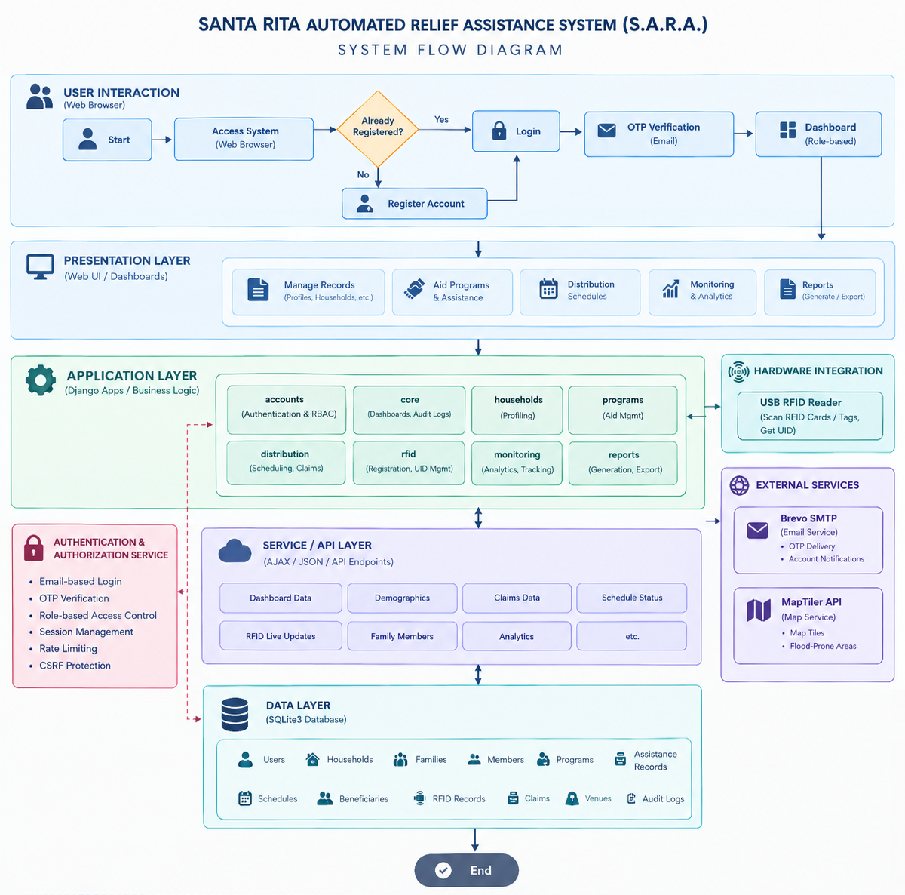
Figure 4.X. System Flow Diagram of S.A.R.A.

The System Flow Diagram shows the overall process of S.A.R.A., starting from user login and OTP verification, followed by role-based access to the system modules. It also shows how the system processes requests, stores and retrieves data, uses RFID and external services when needed, and provides the appropriate system output.

d. Use Case Diagram
The Use Case Diagram presents the major interactions between the users and the Santa Rita Automated Relief Assistance System (S.A.R.A.). It identifies the different actors who interact with the system and shows the functions available to them based on their assigned roles. The system has three primary user roles: MSWDO Admin, MSWDO Staff, and Barangay Admin, while the Beneficiary is represented as an external actor for RFID-based distribution.

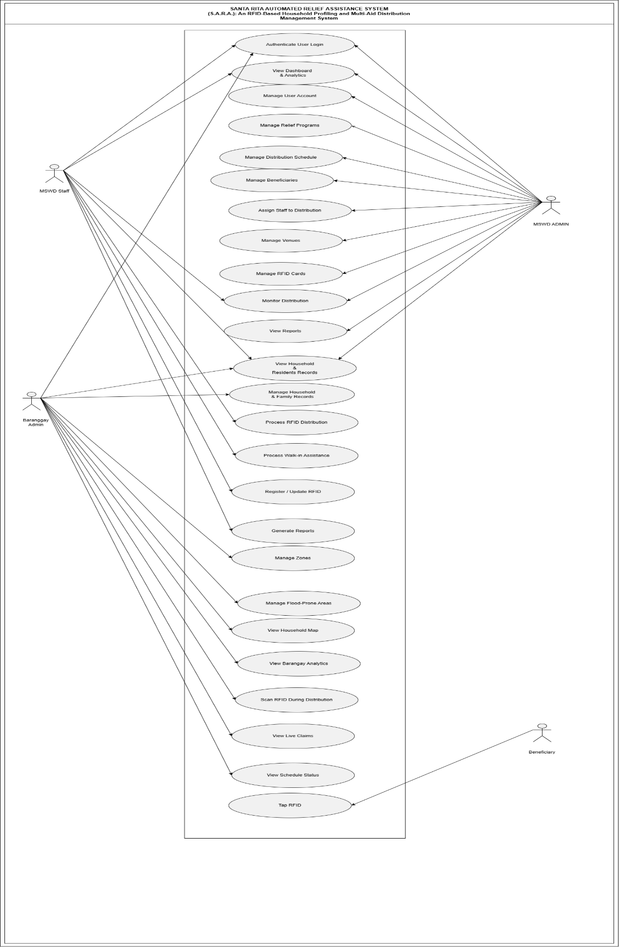
Figure 4.X. Use Case Diagram of S.A.R.A.

The diagram illustrates the major functions of S.A.R.A., including user authentication, dashboard access, household and family record management, aid program management, distribution scheduling, beneficiary management, RFID operations, monitoring, reporting, and other administrative functions. Access to these functions is controlled according to the user's assigned role and scope. For example, the MSWDO Admin has municipal-wide administrative access, while MSWDO Staff and Barangay Admin have more limited operational and barangay-based access.

Identification of System Actors
Figure 4.X. Identification of System Actors of S.A.R.A
Actor | Description
MSWDO Admin | The main administrator of the system with municipal-wide access to system management, programs, schedules, beneficiaries, users, monitoring, reporting, and audit-related functions.
MSWDO Staff | Operational personnel responsible for household profiling, RFID operations, distribution processing, monitoring, and reporting within their permitted scope.
Barangay Admin | Barangay-level user who manages records and performs authorized activities within the assigned barangay, particularly for delegable programs and assigned schedules.
Beneficiary | External actor who interacts with the system during RFID-based distribution by presenting or using an RFID card for identification and claim processing.

The role-based access rules are implemented through explicit role checks and barangay scoping. MSWDO Admin has full access, MSWDO Staff is provided operational access, and Barangay Admin is restricted to the assigned barangay and authorized delegable activities.

Identification of Major Use Cases
The existing diagram contains the following major and supporting use cases:
Figure 4.X. Identification of Major Use Cases of S.A.R.A
No. | Use Case
1 | Authenticate User Login
2 | View Dashboard & Analytics
3 | Manage User Account
4 | Manage Relief Programs
5 | Manage Distribution Schedule
6 | Manage Beneficiaries
7 | Assign Staff to Distribution
8 | Manage Venues
9 | Manage RFID Cards
10 | Monitor Distribution
11 | View Reports
12 | View Household & Residents Records
13 | Manage Household & Family Records
14 | Process RFID Distribution
15 | Process Walk-in Assistance
16 | Register / Update RFID
17 | Generate Reports
18 | Manage Zones
19 | Manage Flood-Prone Areas
20 | View Household Map
21 | View Barangay Analytics
22 | Scan RFID During Distribution
23 | View Claims
24 | View Schedule Status
25 | Tap RFID

Major Use Case Descriptions
To keep the documentation focused, the following tables describe the major use cases represented in the diagram. Smaller supporting functions remain shown in the diagram but do not require a separate full description.

Use Case 1 – Authenticate User Login
Element | Description
Use Case Name | Authenticate User Login
Actor | MSWDO Admin, MSWDO Staff, Barangay Admin
Purpose | To verify the identity of a user and provide secure access to the system.
Preconditions | The user must have a registered and active account.
Main Flow | The user enters the email and password, the system validates the credentials, an OTP is sent through email, the user enters the OTP, and the system verifies the OTP before granting access.
Alternative Flow | Invalid credentials or an invalid OTP results in an error or verification failure. Repeated failed attempts may trigger rate limiting or lockout.
Postconditions | The authenticated user is directed to the appropriate dashboard based on the assigned role.
Figure 4.X. Use Case 1 of S.A.R.A

Use Case 2 – View Dashboard & Analytics
Element | Description
Use Case Name | View Dashboard & Analytics
Actor | MSWDO Admin, MSWDO Staff, Barangay Admin
Purpose | To provide users with information and statistics relevant to their role and access scope.
Preconditions | The user must be successfully authenticated.
Main Flow | The user accesses the dashboard, the system retrieves the appropriate statistics and information, and the results are displayed through dashboard components and analytics.
Alternative Flow | If the requested information is unavailable, the system displays the available data or an appropriate message.
Postconditions | The user can view the authorized dashboard information and analytics.
Figure 4.X. Use Case 2 of S.A.R.A

Use Case 3 – Manage User Account
Element | Description
Use Case Name | Manage User Account
Actor | MSWDO Admin
Purpose | To manage system user accounts and their access.
Preconditions | The MSWDO Admin must be authenticated and authorized to manage users.
Main Flow | The administrator opens user management, creates or views an account, updates account information or status, and saves the changes.
Alternative Flow | The system rejects invalid information or prevents deletion when account safety conditions are not satisfied.
Postconditions | The user account is created, updated, activated, deactivated, or deleted according to the administrator's action.
Figure 4.X. Use Case 3 of S.A.R.A

Use Case 4 – Manage Relief Programs
Element | Description
Use Case Name | Manage Relief Programs
Actor | MSWDO Admin
Purpose | To configure and maintain aid programs, categories, assistance, and eligibility rules.
Preconditions | The administrator must be authenticated and authorized to manage programs.
Main Flow | The administrator creates or edits a relief program, adds aid categories and assistance, configures requirements, and activates or deactivates the applicable items.
Alternative Flow | Invalid or conflicting program information is rejected by the system.
Postconditions | The updated aid-program configuration becomes available for authorized system processes.
Figure 4.X. Use Case 4 of S.A.R.A

Use Case 5 – Manage Household & Family Records
Element | Description
Use Case Name | Manage Household & Family Records
Actor | MSWDO Admin, MSWDO Staff, Barangay Admin
Purpose | To maintain accurate household, family, and resident information.
Preconditions | The user must be authenticated and have permission to manage household records.
Main Flow | The user searches for or creates a household, enters or updates family and member information, and saves the record.
Alternative Flow | Invalid information is rejected through form or model validation. Archived families are restricted from selected operations.
Postconditions | The household, family, or member information is stored or updated in the database.
Figure 4.X. Use Case 5 of S.A.R.A

Use Case 6 – Manage Distribution Schedule
Element | Description
Use Case Name | Manage Distribution Schedule
Actor | MSWDO Admin
Purpose | To create and manage schedules for relief distribution activities.
Preconditions | The administrator must be authenticated and authorized to manage schedules.
Main Flow | The administrator creates a schedule, selects the assistance and location, sets the date, budget, and prioritization strategy, and confirms the schedule.
Alternative Flow | The system prevents invalid dates, conflicting operations, or changes that are restricted after beneficiary lists or claims exist.
Postconditions | The distribution schedule is created or updated and becomes available for the corresponding operational activities.
Figure 4.X. Use Case 6 of S.A.R.A

Use Case 7 – Manage Beneficiaries
Element | Description
Use Case Name | Manage Beneficiaries
Actor | MSWDO Admin
Purpose | To generate, review, finalize, and maintain beneficiary lists for distribution.
Preconditions | A valid distribution schedule and assistance configuration must be available.
Main Flow | The administrator generates a beneficiary list, the system evaluates eligible candidates, and the administrator reviews, confirms, or finalizes the resulting list.
Alternative Flow | Duplicate entries may be resolved, and manual additions or removals may be performed when permitted.
Postconditions | A validated beneficiary list is stored and used during distribution processing.
Figure 4.X. Use Case 7 of S.A.R.A

Use Case 8 – Process RFID Distribution
Element | Description
Use Case Name | Process RFID Distribution
Actor | MSWDO Admin, MSWDO Staff, Barangay Admin, Beneficiary
Purpose | To identify an eligible beneficiary and process a relief claim using RFID-supported distribution.
Preconditions | A valid distribution schedule must exist, the user must have the required access, and the beneficiary must satisfy the applicable requirements.
Main Flow | The beneficiary presents an RFID card, the RFID UID is read, the system retrieves the associated record, checks eligibility and distribution conditions, and records the claim when all requirements are satisfied.
Alternative Flow | The claim may be rejected if the schedule is closed, the family is archived, the beneficiary is not listed, the user is not assigned, or the beneficiary has already claimed.
Postconditions | A valid claim is recorded and the related distribution information is updated.
Figure 4.X. Use Case 8 of S.A.R.A

Use Case 9 – Process Walk-in Assistance
Element | Description
Use Case Name | Process Walk-in Assistance
Actor | MSWDO Admin, MSWDO Staff
Purpose | To process assistance for beneficiaries who are handled through the walk-in procedure.
Preconditions | The authorized staff member must be logged in and the beneficiary must have an identifiable record.
Main Flow | The staff searches for the family or beneficiary, selects the applicable assistance, verifies the transaction information, and records the walk-in claim.
Alternative Flow | Additional verification or family reactivation may be required for eligible late claims.
Postconditions | The walk-in assistance transaction is recorded in the system.
Figure 4.X. Use Case 9 of S.A.R.A

Use Case 10 – Monitor Distribution
Element | Description
Use Case Name | Monitor Distribution
Actor | MSWDO Admin, MSWDO Staff
Purpose | To monitor claims, schedules, distribution progress, and related statistics.
Preconditions | The user must be authenticated and authorized to access monitoring functions.
Main Flow | The user opens the monitoring interface, the system retrieves current distribution information, and the results are displayed through status information, statistics, and monitoring views.
Alternative Flow | Data may be filtered according to available monitoring criteria such as date, barangay, program, or assistance.
Postconditions | The user can review the current distribution status and available monitoring information.
Figure 4.X. Use Case 10 of S.A.R.A

Use Case 11 – Generate Reports
Element | Description
Use Case Name | Generate Reports
Actor | MSWDO Admin, MSWDO Staff, Barangay Admin
Purpose | To produce system reports based on stored distribution and beneficiary information.
Preconditions | The user must be authenticated and have permission to access the requested report.
Main Flow | The user selects a report type and applicable filters, the system gathers the required data, generates the report, and provides the resulting output.
Alternative Flow | The system displays an appropriate message when no matching data is available or when the requested report is outside the user's access scope.
Postconditions | The requested report is generated and may be viewed or exported when permitted.
Figure 4.X. Use Case 11 of S.A.R.A

Actor-to-Use-Case Relationships
The major relationships between the actors and system functions are summarized below:
Use Case | MSWDO Admin | MSWDO Staff | Barangay Admin | Beneficiary | Use Case
Authenticate User Login | ✓ | ✓ | ✓ | — | Authenticate User Login
View Dashboard & Analytics | ✓ | ✓ | ✓ | — | View Dashboard & Analytics
Manage User Account | ✓ | — | — | — | Manage User Account
Manage Relief Programs | ✓ | — | — | — | Manage Relief Programs
Manage Household & Family Records | ✓ | ✓ | ✓ | — | Manage Household & Family Records
Manage Distribution Schedule | ✓ | View | View | — | Manage Distribution Schedule
Manage Beneficiaries | ✓ | — | — | — | Manage Beneficiaries
Assign Staff to Distribution | ✓ | — | — | — | Assign Staff to Distribution
Manage Venues | ✓ | — | — | — | Manage Venues
Manage RFID Cards | ✓ | ✓ | — | — | Manage RFID Cards
Monitor Distribution | ✓ | ✓ | Limited | — | Monitor Distribution
View Reports | ✓ | ✓ | ✓ | — | View Reports
Process RFID Distribution | ✓ | ✓ | ✓ | ✓ | Process RFID Distribution
Process Walk-in Assistance | ✓ | ✓ | — | — | Process Walk-in Assistance
Register / Update RFID | ✓ | ✓ | — | — | Register / Update RFID
Generate Reports | ✓ | ✓ | ✓ | — | Generate Reports

Include and Extend Relationships
The current Use Case Diagram does not explicitly present <<include>> or <<extend>> relationships. The diagram primarily uses direct actor-to-use-case associations to show which users can access each system function. This approach is appropriate for the current diagram because the main purpose is to present the major actors and their corresponding system functions without unnecessarily increasing diagram complexity.
Summary
Overall, the Use Case Diagram shows how S.A.R.A. supports the different responsibilities of the MSWDO, its staff, barangay administrators, and beneficiaries. The diagram connects the users to the major system functions while reflecting the role-based access rules implemented in the system.
e. Data Flow Diagram (DFD)
The Data Flow Diagram (DFD) illustrates how data moves within the Santa Rita Automated Relief Assistance System (S.A.R.A.). It presents the interaction between the system and its external entities, the major processes performed by the system, the data stored and retrieved, and the information exchanged between users and system components.
The DFD is presented at different levels to provide a clearer representation of the system. The Context Diagram presents the overall interaction between S.A.R.A. and its external entities, while the Level 1 DFD breaks down the major processes of the system into more detailed data flows and data stores.
1. Context Diagram / Level 0
The Context Diagram presents S.A.R.A. as a single system process and shows its interaction with the primary external entities. These entities include the MSWDO Admin, MSWDO Staff, Barangay Admin, and Resident/Beneficiary.

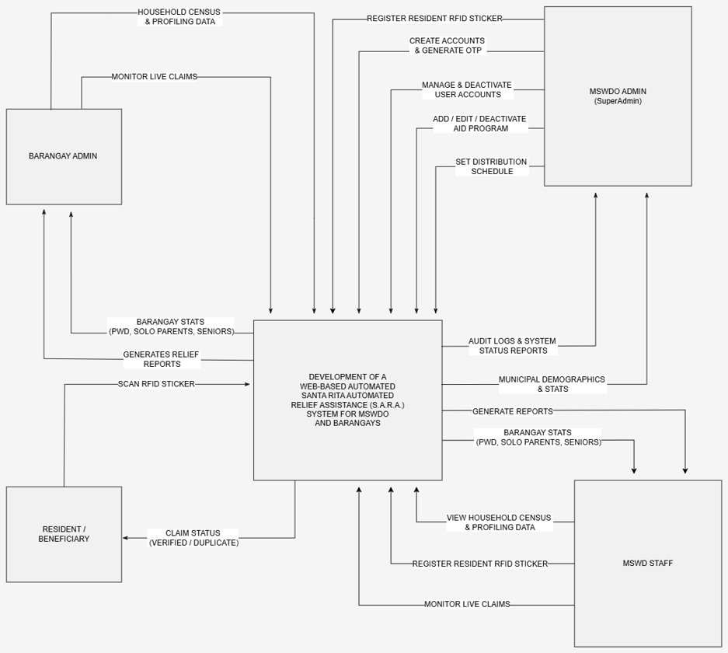
Figure 4.X. Context Diagram of S.A.R.A

The MSWDO Admin provides administrative information such as user account management, aid program configuration, distribution schedules, and requests for reports and analytics. The MSWDO Staff interacts with the system for household profiling, RFID registration, distribution processing, monitoring, and reporting. The Barangay Admin accesses barangay-level household information, RFID-related functions, distribution monitoring, and authorized reports. The Resident/Beneficiary interacts with the system primarily through distribution and RFID-based claim verification.
2. Level 1 Data Flow Diagram
The Level 1 DFD decomposes the S.A.R.A. system into its major functional processes. These processes include User Authentication and Account Management, Dashboard and Analytics, Household and Resident Management, RFID Card Management, Distribution Scheduling and Operations, Monitoring and Live Tracking, and Reporting.

Figure 4.X. Level 1 Data Flow Diagram of S.A.R.A.
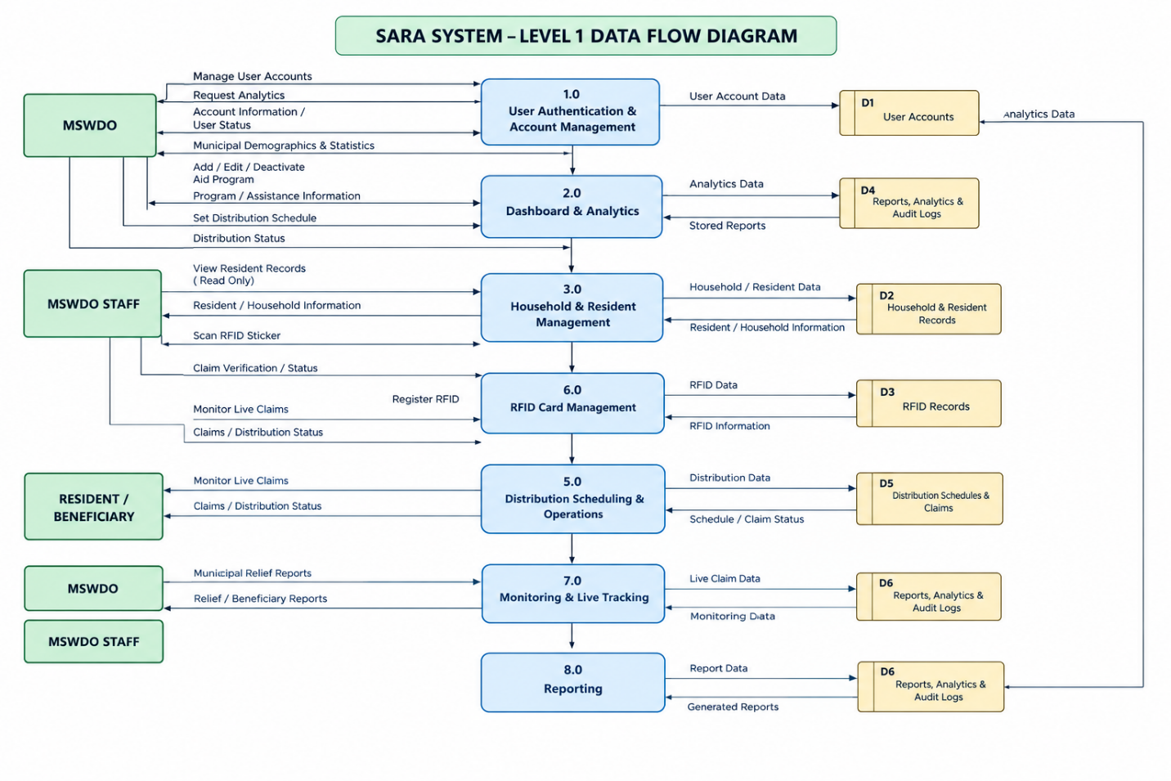

The Level 1 DFD shows how information is exchanged between users and the major system processes. User account information is processed through authentication and account management, while dashboard and analytics functions retrieve system information for authorized users. Household and resident information is handled through the household management process, while RFID-related information is processed through RFID management and distribution operations.
Distribution data is used for scheduling, beneficiary processing, and claim transactions. Monitoring functions receive live claim and distribution information, while the reporting process generates reports based on the available system data.

3. Major External Entities
External Entity | Description
MSWDO Admin | Manages users, aid programs, distribution schedules, beneficiaries, monitoring, and administrative reports.
MSWDO Staff | Performs household profiling, RFID operations, distribution processing, monitoring, and operational reporting.
Barangay Admin | Manages and views authorized barangay-level information and performs delegated distribution-related functions.
Resident/Beneficiary | Participates in relief distribution and is identified through the RFID-supported claim process.

4. Major Processes
Process | Description
1.0 User Authentication & Account Management | Handles login, OTP verification, user accounts, and account-related functions.
2.0 Dashboard & Analytics | Processes dashboard information, statistics, and analytics.
3.0 Household & Resident Management | Handles household, family, and resident records.
5.0 Distribution Scheduling & Operations | Handles distribution schedules, beneficiary processing, and claim-related activities.
6.0 RFID Card Management | Handles RFID registration, updating, and related RFID information.
7.0 Monitoring & Live Tracking | Handles live claim monitoring, distribution status, and analytics.
8.0 Reporting | Generates system reports and report-related outputs.

5. Data Stores
The Level 1 DFD uses the following logical data stores:
Data Store | Stored Information
D1 – User Accounts | User accounts, roles, and account information
D2 – Household & Resident Records | Household, family, and resident information
D3 – RFID Records | RFID assignments and RFID-related information
D4 – Reports, Analytics & Audit Logs | Report data, analytics-related information, and audit records
D5 – Distribution Schedules & Claims | Distribution schedules, beneficiaries, and claim information
D6 – Monitoring Data | Live claim and distribution monitoring information

f. Database Design
The Database Design of the Santa Rita Automated Relief Assistance System (S.A.R.A.) presents the structure and organization of the data used by the system. It defines the entities, attributes, primary keys, foreign keys, relationships, and data organization required to support the system's major functions. The database is designed to manage user accounts, barangay and household information, family and resident profiles, aid programs, eligibility rules, distribution schedules, beneficiaries, RFID records, claims, monitoring-related information, reports, and audit records.
The database design corresponds to the actual data structures implemented in the system and is represented through the Entity Relationship Diagram (ERD) and database table schema.
1. Entity Relationship Diagram
Figure 4.X. Entity Relationship Diagram of S.A.R.A

The ERD illustrates the relationships among the different entities used by S.A.R.A. It shows how information is connected through primary and foreign keys. The design separates the major areas of the system into user management, geographical and household profiling, aid-program management, distribution operations, RFID management, reporting, and auditing.
The ERD also shows the relationships between higher-level entities and their related records. For example, a barangay may contain multiple zones and households, a household may contain families, and a family may have multiple family members. Similarly, a program may contain several aid categories and assistance records, while assistance may be associated with eligibility rules and distribution schedules.

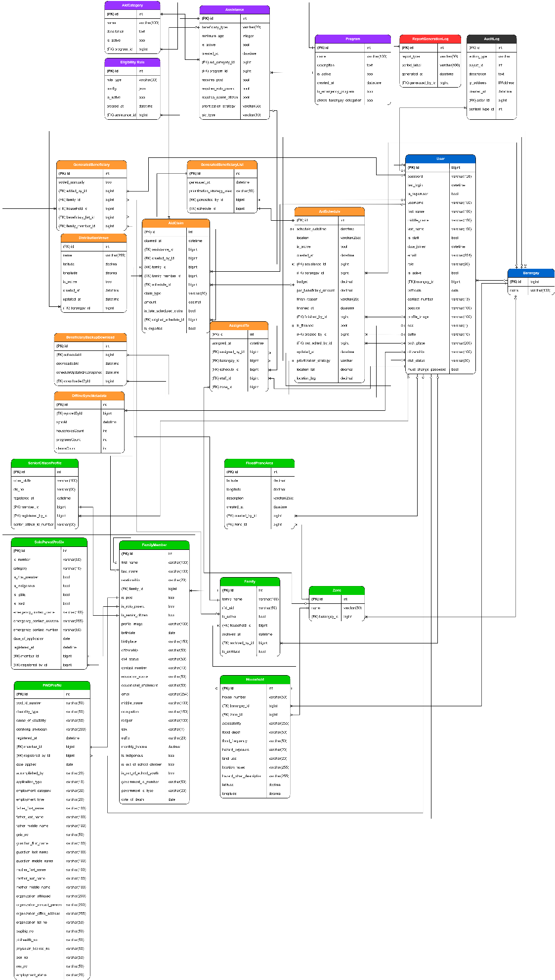

The ERD illustrates the relationships among the different entities used by S.A.R.A. It shows how information is connected through primary and foreign keys. The design separates the major areas of the system into user management, geographical and household profiling, aid-program management, distribution operations, RFID management, reporting, and auditing.
The ERD also shows the relationships between higher-level entities and their related records. For example, a barangay may contain multiple zones and households, a household may contain families, and a family may have multiple family members. Similarly, a program may contain several aid categories and assistance records, while assistance may be associated with eligibility rules and distribution schedules.

2. Identification of Entities
The database consists of the following major entities:
Entity | Description
Barangay | Stores the barangay or administrative area information.
User | Stores system account information, user roles, and account details.
Zone | Stores zones associated with a barangay.
Household | Stores household information, location, accessibility, and hazard-related information.
Family | Stores family-unit information and RFID assignment within a household.
FamilyMember | Stores individual resident and demographic information.
PWDProfile | Stores additional information for registered persons with PWD status.
SoloParentProfile | Stores additional information for registered solo parents.
SeniorCitizenProfile | Stores additional information for senior citizens.
Program | Stores information about available aid programs.
AidCategory | Stores categories under an aid program.
Assistance | Stores specific assistance offerings under a program and category.
EligibilityRule | Stores the eligibility conditions applied to assistance.
AidSchedule | Stores information about scheduled relief distributions.
GeneratedBeneficiaryList | Stores generated beneficiary-list information for a distribution schedule.
GeneratedBeneficiary | Stores the individual entries included in a beneficiary list.
AssignedTo | Stores staff assignments for distribution schedules.
AidClaim | Stores records of assistance claims and distribution transactions.
DistributionVenue | Stores registered distribution locations.
BeneficiaryBackupDownload | Tracks downloads of beneficiary-list backups.
OfflineSyncMetadata | Stores information related to offline synchronization activities.
AuditLog | Stores system activities and security/audit events.
ReportGenerationLog | Stores records of report-generation activities.

3. Attributes
Each entity contains attributes that describe the information stored in the corresponding table. The database tables show the field names and their respective data types.
The major groups of attributes are as follows:
User and Administrative Data
The User entity contains account and personal information such as user ID, password, username, name, email, role, active status, barangay assignment, contact number, position, profile image, birth information, citizenship, civil status, and password-change status.
The Barangay and Zone entities contain the names and identifiers required to organize users, households, and other barangay-related records geographically.
Household and Resident Data
The Household entity contains information such as house number, barangay, zone, accessibility, flood depth, flood frequency, hazard exposure, land use, location notes, and geographic coordinates.
The Family entity identifies the family within a household and stores information related to RFID assignment, activation, and archiving.
The FamilyMember entity contains resident-level information, including name, relationship, birthdate, sex, civil status, contact information, education, occupation, monthly income, government identification, and demographic category indicators.
The PWDProfile, SoloParentProfile, and SeniorCitizenProfile entities contain additional information for their respective special-category profiles.
Aid Program and Eligibility Data
The Program entity stores information such as program name, description, activation status, emergency-program status, and barangay-delegation settings.
The AidCategory entity stores the categories under a program, while the Assistance entity contains the specific assistance information, beneficiary type, minimum age, aid type, prioritization strategy, and special-category requirements.
The EligibilityRule entity stores configurable rules used to determine whether a beneficiary qualifies for a particular assistance.
Distribution and Claim Data
The AidSchedule entity contains the schedule date and time, location, associated assistance, barangay, budget, amount per beneficiary, completion information, prioritization strategy, and geographic coordinates.
The GeneratedBeneficiaryList and GeneratedBeneficiary entities store generated beneficiary information associated with a distribution schedule.
The AssignedTo entity records staff assignments to a schedule, including the assigned staff member, barangay, and zone.
The AidClaim entity records actual assistance claims, including the claim date, assistance, family or family member, schedule, claim type, amount, and other transaction-related information.
4. Primary Keys
A primary key (PK) is used to uniquely identify each record in a table. In the S.A.R.A. database, the entities generally use an id field as their primary key.
Entity | Primary Key
Barangay | id
User | id
Zone | id
Household | id
Family | id
FamilyMember | id
PWDProfile | id
SoloParentProfile | id
SeniorCitizenProfile | id
Program | id
AidCategory | id
Assistance | id
EligibilityRule | id
AidSchedule | id
GeneratedBeneficiaryList | id
GeneratedBeneficiary | id
AssignedTo | id
AidClaim | id
DistributionVenue | id
BeneficiaryBackupDownload | id

5. Foreign Keys
Foreign keys (FKs) are used to establish relationships between related entities. They allow the database to connect records while maintaining referential relationships.
Major foreign-key relationships in the database include:
Entity | Foreign Key | References
User | barangay_id | Barangay
Zone | barangay_id | Barangay
Household | barangay_id | Barangay
Household | zone_id | Zone
Family | household_id | Household
FamilyMember | family_id | Family
PWDProfile | member_id | FamilyMember
PWDProfile | registered_by_id | User
SoloParentProfile | member_id | FamilyMember
SoloParentProfile | registered_by_id | User
SeniorCitizenProfile | member_id | FamilyMember
SeniorCitizenProfile | registered_by_id | User
AidCategory | program_id | Program
Assistance | aid_category_id | AidCategory
Assistance | program_id | Program
EligibilityRule | assistance_id | Assistance
AidSchedule | assistance_id | Assistance
AidSchedule | barangay_id | Barangay
GeneratedBeneficiaryList | schedule_id | AidSchedule
GeneratedBeneficiary | beneficiary_list_id | GeneratedBeneficiaryList
GeneratedBeneficiary | family_id | Family
GeneratedBeneficiary | household_id | Household
GeneratedBeneficiary | family_member_id | FamilyMember
AidClaim | assistance_id | Assistance
AidClaim | family_id | Family
AidClaim | family_member_id | FamilyMember
AidClaim | schedule_id | AidSchedule
AssignedTo | schedule_id | AidSchedule
AssignedTo | staff_id | User
AssignedTo | barangay_id | Barangay
AssignedTo | zone_id | Zone
DistributionVenue | barangay_id | Barangay
ReportGenerationLog | generated_by_id | User
AuditLog | actor_id | User

The foreign keys allow related data to be connected without unnecessarily duplicating the same information across multiple tables.

6. Relationships and Cardinality
The database uses one-to-many and one-to-one relationships among entities depending on the nature of the information being stored.
The major relationships are:
Relationship | Cardinality | Description
Barangay → User | 1:M | One barangay can have multiple users.
Barangay → Zone | 1:M | One barangay can contain multiple zones.
Barangay → Household | 1:M | One barangay can contain multiple households.
Zone → Household | 1:M | One zone can contain multiple households.
Household → Family | 1:M | One household can contain multiple families.
Family → FamilyMember | 1:M | One family can have multiple family members.
FamilyMember → PWDProfile | 1:1 | A family member may have one corresponding PWD profile.
FamilyMember → SoloParentProfile | 1:1 | A family member may have one corresponding solo-parent profile.
FamilyMember → SeniorCitizenProfile | 1:1 | A family member may have one corresponding senior-citizen profile.
Program → AidCategory | 1:M | One program may contain multiple aid categories.
Program → Assistance | 1:M | One program may have multiple assistance records.
AidCategory → Assistance | 1:M | One category may contain multiple assistance records.
Assistance → EligibilityRule | 1:M | One assistance may have multiple eligibility rules.
Assistance → AidSchedule | 1:M | One assistance can be used in multiple distribution schedules.
AidSchedule → GeneratedBeneficiaryList | 1:M | A schedule may have generated beneficiary-list records.
GeneratedBeneficiaryList → GeneratedBeneficiary | 1:M | One beneficiary list may contain multiple beneficiaries.
AidSchedule → AssignedTo | 1:M | One schedule may have multiple staff assignments.
AidSchedule → AidClaim | 1:M | One schedule may have multiple claims.
Family → AidClaim | 1:M | One family may have multiple claim records over time.
FamilyMember → AidClaim | 1:M | A family member may have multiple individual assistance claims.
Barangay → DistributionVenue | 1:M | A barangay may have multiple registered venues.
User → AuditLog | 1:M | One user may generate multiple audit records.
User → ReportGenerationLog | 1:M | One user may generate multiple reports.

These relationships reflect the operational structure of the system and allow related records to be retrieved and managed through their corresponding foreign-key connections.

7. Database Schema
The database schema is composed of the tables shown in the database-table representation of S.A.R.A. Each table contains a primary key and, where necessary, foreign keys that connect it to other tables.
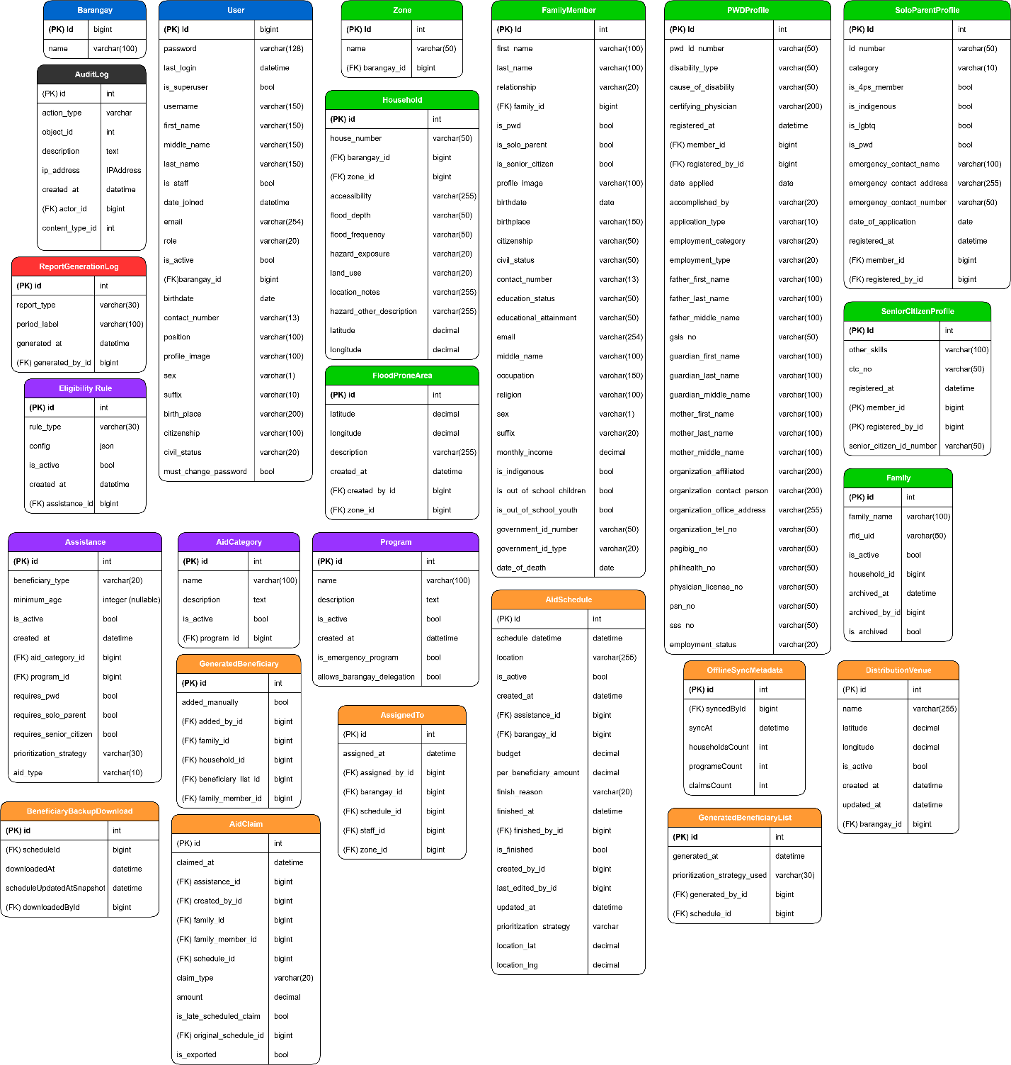
Figure 4.X. Database Tables and Schema of S.A.R.A.

Group | Main Tables
User and Administration | User, Barangay, AuditLog, ReportGenerationLog
Household and Resident Management | Zone, Household, Family, FamilyMember, PWDProfile, SoloParentProfile, SeniorCitizenProfile
Aid Program Management | Program, AidCategory, Assistance, EligibilityRule
Distribution Management | AidSchedule, AssignedTo, DistributionVenue, GeneratedBeneficiaryList, GeneratedBeneficiary, AidClaim
RFID and Offline Support | Family, AidClaim, BeneficiaryBackupDownload, OfflineSyncMetadata
Monitoring and Reporting | AuditLog, ReportGenerationLog, AidClaim, GeneratedBeneficiaryList

The schema supports the system's major processes by allowing information to be stored once and referenced by related tables through foreign keys.
8. Data Integrity and Constraints
The database design incorporates constraints to help maintain data consistency and prevent invalid or duplicate records.
The implemented system uses unique constraints for selected fields and combinations, including user email, RFID UID, aid categories, assistance records, and staff assignments. Foreign keys are also used to maintain relationships among dependent records.
The system additionally applies transaction controls during important operations. For example, claim processing uses atomic transactions, while RFID registration and updating use row-level locking to reduce the risk of concurrent registration conflicts.
The database also supports the use of soft deletion for family records through an archive flag. This allows historical information to be retained while preventing archived families from participating in applicable RFID and claim operations.
9. Normalization
The database follows a relational structure in which data is separated into entities according to their specific functions. Related information is connected through foreign keys rather than repeatedly storing the same information in unrelated tables.
10. Summary of the Database Design
Overall, the database design provides the data foundation of S.A.R.A. The ERD defines how the entities are related, while the database schema defines the tables, fields, primary keys, foreign keys, and data types used in the implementation. The structure supports household profiling, aid-program management, beneficiary generation, distribution scheduling, RFID-supported claims, monitoring, reporting, and audit logging.
The database design is therefore directly connected to the functional requirements and system processes presented in the preceding sections.

g. User Interface and User Experience
The User Interface and User Experience of S.A.R.A. were designed to provide a clear, consistent, and easy-to-use interface for the system's different users. The system includes dashboards, navigation menus, forms, record-management pages, reports, notifications, and other interfaces needed for household profiling, aid distribution, monitoring, and administration. The interface supports ease of use, accessibility, consistent navigation, learnability, error prevention, and user feedback to help users complete tasks efficiently and understand the results of their actions.

h. System Navigation Structure
MSWDO Admin Navigation Structure




















Super Admin Functions
(System Administrator)

LOGIN
(Authentication)

DASHBOARD
(Overview)

User Management
(Add/ Deact)

Household Profiling
(Beneficiary Data)

Aid Programs
(Manage Aid, Set Sched, Gen List)

Analytics
(Charts & Graphs)

Settings
(Account Config)

Barangays
(Barangay Infos)

Audit Logs
(Actor Monitoring)

Log Out
(End)
Schedule Distribution
(Set/Edit/Cancel Sched)
Beneficiary Selection
(Manage List, Assign Staff)
Manage Programs
(Manage Aid Programs)
Residents

(Search/View Residents Municipal-Wide)
Household Map
Filter and View Pinpointed Households
RFID Registration
(Register RFID UID Per Family Across All Barangays)

Reports
(View Aid Claims)

MSWDO Staff Navigation Structure
Figure 4.X MSWDO Staff Navigation Structure of S.A.R.A.




LOGIN
(Authentication)

DASHBOARD
(Overview)

Settings
(Account Config)

Log Out
(End)
Residents

(Search/View Residents Municipal-Wide)
Household Map
Filter and View Pinpointed Households
RFID Registration
(Register RFID UID Per Family Across All Barangays)

MSWDO Staff Functions
(System Sub Administrator)

Walk-In Assistance
(Tap RFID / Distribute)
Analytics Overview
(Graphs/Records Filtering)
Reports
(View/Generate Reports)
Programs
(View Aid Programs)

Household Profile
(Beneficiary Data)
My Distributions
(View Assigned Scheds)

Aid Programs
(Manage Aid, Set Sched, Gen List)

Barangay Admin Navigation Structure

Figure 4.X Barangay Admin Navigation Structure of S.A.R.A.

LOGIN
(Authentication)

DASHBOARD
(Overview)

Settings
(Account Config)

Barangay Admin Functions
(System Sub Administrator)

Log Out
(End)

Zones
(View Barangay-Level Zones)

Household Profile
(Beneficiary Data)
Residents

(Search/View Residents Barangay-Level)
My Distributions
(View Assigned Scheds)

Analytics
(Aid Claims Summary)

Reports

(Barangay Level View/Generate Reports)

Household Map
(View Pinpoint Brngy House Locations)

i. Application Programming Interface (API) Design
The Application Programming Interface (API) of S.A.R.A. provides the communication mechanism between the system interface and selected backend functions. The implemented API endpoints support functions such as dashboard analytics, demographic information, monthly claim data, live claim monitoring, schedule status, and family-member information. The following tables present the implemented API endpoints, their purposes, authentication requirements, and expected responses.

Accounts App
Method | Endpoint | Purpose | Authentication | Expected Response
GET | /check-session/ | Check if user is authenticated | @login_required, session-based check | 200 OK (authenticated: true) or 401 (authenticated: false)

Core App
Method | Endpoint | Purpose | Authentication | Expected Response
GET | /mswdo/api/demographics/<str:category>/ | Retrieve residents by demographic category (PWD, Solo Parent, Senior) | @login_required, @session_protected, @mswdo_or_staff_required | 200 OK or 400 (invalid category)
GET | /mswdo/api/monthly-claims/<str:month>/ | Retrieve claims breakdown by program for a specific month (ISO format: YYYY-MM) | @login_required, @session_protected, @mswdo_or_staff_required | 200 OK or 400 (invalid month/format)
GET | /mswdo/api/analytics-chart-data/ | Retrieve analytics chart data, optionally filtered by barangay | @login_required, @session_protected, @mswdo_or_staff_required | 200 OK or 404 (barangay not found)
GET | /api/sector-age-data/ | Retrieve sex counts and 10-sector life-stage breakdown (BARANGAY forced to own barangay) | @login_required, @session_protected | 200 OK or 400 (invalid barangay)

Distribution App
Method | Endpoint | Purpose | Authentication | Expected Response
POST | /mswdo/schedule/int:schedule_id/rfid/scan/ | Process RFID scan for scheduled distribution (JSON behavior for POST/AJAX) | @login_required, @session_protected, staff assignment check | 200 OK or 400/403 (error/access denied)
GET | /mswdo/search-staff/ | Search for MSWDO_STAFF users (AJAX) | @login_required, @session_protected, MSWDO role only | 200 OK or 403 (access denied)
GET | /mswdo/schedule/int:schedule_id/beneficiaries/search/ | Search for eligible beneficiaries (AJAX) | @login_required, @session_protected, MSWDO/MSWDO_STAFF with staff assignment check | 200 OK or 403 (access denied)
GET | /staff/walkin/rfid/ | Lookup family by RFID for walk-in assistance (AJAX) | @login_required, @session_protected, MSWDO_STAFF only | 200 OK or 403/400 (access denied/no RFID)
POST | /staff/walkin/reactivate-family/ | Reactivate archived family for walk-in assistance (AJAX) | @login_required, @session_protected, MSWDO_STAFF only | 200 OK or 403/405/400 (access denied/invalid method/not found)
POST | /staff/walkin/claim/ | Process walk-in assistance claim (AJAX) | @login_required, @session_protected, MSWDO_STAFF only | 200 OK or 400/403 (validation error/access denied)
GET | /staff/search-assistance/ | Search for active assistance programs (AJAX) | @login_required, @session_protected, MSWDO_STAFF only | 200 OK or 403 (access denied)

Households App
Method | Endpoint | Purpose | Authentication | Expected Response
GET | /barangay/zones/int:zone_id/flood-prone-areas/api/ | Get flood-prone areas for a zone (AJAX) | @login_required, @session_protected, BARANGAY role only (own barangay) | 200 OK or 403 (access denied)
POST | /barangay/zones/int:zone_id/flood-prone-areas/api/ | Create/update/delete flood-prone areas (AJAX) | @login_required, @session_protected, BARANGAY role only (own barangay) | 200 OK or 400/403/405 (error/access denied/invalid method)
GET | /map/data/ | Get household map data with vulnerability flags | @login_required, @session_protected | 200 OK

Monitoring App
Method | Endpoint | Purpose | Authentication | Expected Response
GET | /mswdo/rfid/live-claims/ | Get real-time claims for active schedule (polling endpoint) | @login_required, @session_protected, BARANGAY scoped to own barangay, MSWDO_STAFF scoped to assigned schedules | 200 OK
GET | /mswdo/schedule/status/ | Get schedule status with staff assignment info | @login_required, @session_protected, @mswdo_or_staff_required | 200 OK
GET | /mswdo/analytics/api/ | Get comprehensive analytics KPIs and trends | @login_required, @session_protected, @mswdo_or_staff_required | 200 OK
GET | /ajax/get-family-members/ | Get family members by RFID and assistance (AJAX) | @login_required, @session_protected | 200 OK
GET | /ajax/get-aid-categories/ | Get aid categories by program (AJAX) | @login_required, @session_protected | 200 OK
GET | /barangay/schedule-status/ | Get schedule status for BARANGAY role | @login_required, @session_protected, BARANGAY role only | 200 OK

Programs App
Method | Endpoint | Purpose | Authentication | Expected Response
POST | /mswdo/programs/assistance/add/ | Add assistance entry via AJAX modal | @login_required, @session_protected, MSWDO role only | 200 OK or 400/405 (validation error/invalid method)
POST | /mswdo/programs/assistance/int:assistance_id/edit/ | Edit assistance entry via AJAX modal | @login_required, @session_protected, MSWDO role only | 200 OK or 400/405 (validation error/invalid method)
GET | /ajax/get-program-category-names/int:program_id/ | Get category names for a program (for datalist autocomplete) | @login_required, MSWDO role only | 200 OK or 403 (access denied)

j. Authentication and Authorization Design
Authentication and authorization are handled through the Accounts module.
The login process uses email-based authentication, followed by OTP verification when enabled. The system also supports password changes, password reset, forced password changes, session protection, and account activation or deactivation.
Authorization is based on the user's role. MSWDO Admin users have municipal-wide access, MSWDO Staff users have operational permissions, and Barangay Admin users are limited to their barangay and authorized delegated functions.
Function | MSWDO Admin | MSWDO Staff | Barangay Admin
Login with OTP | ✓ | ✓ | ✓
User Management | ✓ | — | —
Household Management | — | — | ✓
Program Management | ✓ | — | —
Distribution Scheduling | ✓ | — | —
Process Claims | — | ✓ | ✓
RFID Management | ✓ | ✓ | —
Monitoring | ✓ | ✓ | ✓
Reports | ✓ | ✓ | ✓
Audit Logs | ✓ | — | —

k. Security Architecture
The Security Architecture of the Santa Rita Automated Relief Assistance System (S.A.R.A.) is designed to protect user accounts, system data, and sensitive operations from unauthorized access and invalid transactions. The system applies multiple security controls, including authentication, role-based authorization, session protection, input validation, CSRF protection, rate limiting, audit logging, and data-integrity safeguards.
Figure 4.X. System Architecture of S.A.R.A
Security Control | Implementation in S.A.R.A.
Authentication | Uses email-based login with password verification and email OTP verification.
Authorization | Uses role-based access control for MSWDO Admin, MSWDO Staff, and Barangay Admin.
Password Protection | Uses Django password validation and requires the current password when changing passwords.
Session Management | Uses protected sessions with configurable timeout and session expiration controls.
Rate Limiting | Limits login and OTP attempts to reduce brute-force attempts.
CSRF Protection | Django CSRF protection is enabled for POST forms.
Input Validation | Uses Django form and model validation, including validation for phone numbers, images, and financial values.
Access Control | Protected views, explicit role checks, and barangay-level data scoping prevent unauthorized access.
Staff Assignment Control | Distribution claim and completion functions verify staff assignments before allowing restricted operations.
Audit Logging | User actions, authentication events, claims, RFID activities, reports, access-denial events, and other important system activities are recorded in the audit log.
Data Integrity | Uses database constraints, atomic transactions, unique constraints, and row locking for selected RFID operations.
Offline Security | Offline operations use controlled import/export processes, staleness detection, and session expiration for DSWD-related imports.
Sensitive Data Protection | RFID UIDs are masked in audit logs to avoid exposing the complete UID.

l. External System Integration
S.A.R.A. integrates with external services to support specific system functions that are not handled entirely within the Django application. The implemented integrations include Brevo SMTP for email-based OTP delivery and MapTiler API for map visualization and geographic data presentation. These services extend the functionality of the system while the main business logic and data management remain within the S.A.R.A. application.
External Integration Table
External System Service | Purpose | Data Exchanged | Communication Method | Authentication Requirements | Security Considerations | Limitations
Brevo SMTP | Sends OTP codes and account-related email notifications. | Recipient email address, OTP-related email content, and account notification messages. | SMTP email service. | Email service credentials/API configuration stored through environment variables. | Credentials are kept outside the source code through environment configuration. OTP is used as an additional authentication step. | Email delivery depends on the availability and configuration of the Brevo email service.
MapTiler API | Provides map tiles and geographic visualization for household and flood-prone-area mapping. | Map coordinates, map requests, and geographic visualization data. | MapTiler API requests. | MapTiler API key. | API key is loaded from an environment variable rather than directly exposed in the application configuration. | Map display depends on MapTiler availability, API access, and valid API-key configuration.

n. Technology Stack
The Technology Stack of S.A.R.A. presents the main technologies used in developing and implementing the system. It identifies the technologies used for the frontend, backend, database, API and system communication, deployment, version control, and testing, together with their respective purposes. The selected technologies were chosen based on their suitability for supporting the system's functionality, security, maintainability, and overall requirements.

Component | Technology | Purpose
Frontend | HTML (Django templates)  CSS  JavaScript  Bootstrap 5.3.2  Bootstrap Icons 1.11.3  Chart.js 4.4.0 / other CDN-specified versions  Leaflet 1.9.4  Leaflet MarkerCluster 1.5.3  MapTiler (streets-v2 tiles)  Google Fonts (IBM Plex Sans) | User interface  Styling and layout  Client-side interactivity and AJAX communication  UI framework  Icon library  Data visualization  Interactive maps  Map clustering  Map tile provider (OSM-based basemaps)  Typography
Backend | Django 6.0  Python 3.14.0 | Web framework, business logic, authentication, routing, and server-side processing  Backend programming language
Database | SQLite 3 (local development) | Data storage
API | Django view-based AJAX/JSON endpoints using JsonResponse for internal frontend-backend communication. | System communication
Hosting | TBA | System deployment
Version Control | Git / Github (https://github.com/anj-zoldyck/SARA.git) | Source code management
Testing | Django TestCase-based tests (8 test files across apps: accounts, core, distribution, households, monitoring, programs, reports, rfid), Selenium IDE TestCase (Browser extension) | Software testing

4. SYSTEM FEATURES AND USER INTERFACE
a. System Users and User Roles
Figure 4.X. System Users and User Roles of S.A.R.A.
User Role | Description | Level of Access | Major Authorized Functions | Restrictions
MSWDO | Top-level administrator for the Municipal Social Welfare and Development Office (MSWDO) | Full system access across all barangays and data | Program management (create/edit/toggle programs, aid categories, assistance), distribution scheduling, staff assignment to schedules, beneficiary selection and manual override, venue management, analytics access, RFID overview & registration, user account management (create users), report viewing, summary report generation, Excel export of household/family/zone data (RBI Form A format). | Cannot manage/edit household and family records (restricted to BARANGAY role only), cannot generate report list of beneficiary or walk-in reports (restricted to MSWDO_STAFF role only), cannot perform offline sync import operations (restricted to MSWDO_STAFF role only).
MSWDO STAFF | MSWDO staff member who assists with distribution operations and report generation | Scoped to own assigned schedules/claims for distribution operations; read access to resident/household data via @mswdo_or_staff_required-protected views. | RFID scanning during scheduled distributions, walk-in assistance processing (RFID lookup, family reactivation, claim processing), report generation (summary, beneficiary list, walk-in reports), beneficiary search assistance, resident/household viewing (read-only), RFID overview & registration, Excel export of household/family/zone data (RBI Form A format), offline sync operations (import beneficiary lists, import full municipal data, export offline claims for reconciliation, import reconciled claims). | Cannot manage programs/assistances, cannot assign other staff to schedules, cannot access other staff's claims in monitoring (claims filtered by created_by), requires staff assignment to a schedule for some distribution operations, cannot manage/edit household and family records, offline sync operations require OFFLINE_MODE=True environment variable (prevents accidental production database writes).
BARANGAY ADMIN | Barangay-level administrator managing local community data and residents | Scoped exclusively to own barangay's households, zones, and families | Manage household and family records (create, edit, archive, unarchive families, add/edit/delete family members), zone management, flood-prone areas management, household map data access, barangay-specific analytics, schedule status viewing, RFID live claims monitoring (filtered to own barangay), summary report generation (for own barangay only), Excel export of household/family/zone data (RBI Form A format, own barangay only), import reconciled claims from offline instance (requires OFFLINE_MODE=True). monitoring (filtered to own barangay) | Cannot access other barangays' data (all queries filtered by request.user.barangay), cannot manage programs/assistances, cannot schedule distributions, no access to MSWDO-level analytics or beneficiary list/walk-in reports, cannot perform beneficiary list or full municipal data imports, offline sync operations require OFFLINE_MODE=True environment variable

b. System Modules and Functional Features
Figure 4.X. System Modules and Functional Features of S.A.R.A.
Module | Major Features | User | Purpose
User Authentication & Account Management | Login with OTP, logout, user creation/activation/deactivation, profile settings, password change, photo upload/remove | All roles (login/settings), MSWDO (user management) | Secure access control and user account lifecycle management
Dashboard & Analytics | Role-specific dashboards, KPIs, demographics charts, monthly trends, audit log viewing (MSWDO only), analytics APIs (demographics, claims, sector/age) | All roles (dashboards), MSWDO/MSWDO_STAFF (analytics APIs), MSWDO (audit logs) | Real-time system status visualization and data aggregation
Household & Resident Management | Household/family/member CRUD (BARANGAY only), zone management, flood-prone areas (BARANGAY only), Excel export (all roles, BARANGAY scoped), household/vulnerability maps, resident search/filtering, mark/unmark member deceased (BARANGAY only) | MSWDO/MSWDO_STAFF (read-only), BARANGAY (full CRUD own barangay) | Foundational resident database management and geographic mapping
Program & Assistance Management | Program listing (MSWDO/MSWDO_STAFF), program CRUD (MSWDO only), aid category management (MSWDO only), assistance entry creation/editing (MSWDO only), activation toggling (MSWDO only), AJAX modal support | MSWDO (full CRUD), MSWDO_STAFF (read-only viewing) | Define and manage aid programs and assistance types
Distribution Scheduling & Operations | Schedule distribution, beneficiary generation/selection, staff assignment (including barangay admins for delegable schedules), RFID scanning kiosk, walk-in assistance, venue management (list: MSWDO/MSWDO_STAFF; add/edit: MSWDO only), distribution completion, offline sync operations (MSWDO_STAFF/BARANGAY) | MSWDO (scheduling/staff assignment/venue CRUD), MSWDO_STAFF (scanning/walk-in/offline sync), BARANGAY (scanning/delegable schedules/offline reconciliation) | Complete distribution lifecycle from scheduling to claim processing
RFID Card Management | RFID registration overview, card assignment to families, duplicate detection, card deactivation (MSWDO only), per-barangay statistics | MSWDO/MSWDO_STAFF (registration), MSWDO (overview/deactivation) | RFID card registration and tracking for distribution operations
Monitoring & Live Tracking | RFID claim monitoring, live claims polling (barangay-filtered for BARANGAY), schedule status, aid barangay detail with progress, comprehensive analytics dashboard, barangay-specific views (delegable schedules only) | MSWDO/MSWDO_STAFF (monitoring/analytics), BARANGAY (live claims/schedule status for delegable schedules) | Real-time distribution activity monitoring and analytics
Reporting | Aid reports overview, distribution claims view, walk-in reports view, PDF summary reports (MSWDO/MSWDO_STAFF/BARANGAY), Excel beneficiary list reports (MSWDO_STAFF only), walk-in reports (MSWDO_STAFF only), distribution claims export (all roles, BARANGAY scoped to delegable schedules) | MSWDO/MSWDO_STAFF (viewing), MSWDO (summary reports), MSWDO_STAFF (beneficiary list/walk-in reports), BARANGAY (summary reports/delegable schedule exports) | Report generation and viewing for documentation and auditing

5. TESTING RESULTS
This section presents the testing conducted to determine whether the developed Santa Rita Automated Relief Assistance System (S.A.R.A.) performs its major functions according to the identified requirements. The testing focused on the system's authentication and family member management functions, and the results were recorded based on the expected and actual behavior of the system.
a. Testing Procedures
The system was tested using functional testing to verify whether the selected features performed according to their intended functions. The testing focused on the Login and Family Member Management features, including adding, editing, and deleting family member records.
The test cases were performed by entering valid and invalid inputs into the system and comparing the actual system response with the expected result. Each test case was marked as Passed when the actual result matched the expected result.
b. Test Cases
The following test cases were conducted to verify the major functions covered during testing.
Test Case ID | Module/Feature | Test Scenario | Expected Result | Actual Result | Status
TC-001 | Login | Valid Credentials | User successfully logs in | User successfully logs in | Passed
TC-002 | Login | Wrong Credentials | Error message is displayed | Error message is displayed | Passed
TC-003 | Login | Wrong Password | Error message is displayed | Error message is displayed | Passed
TC-004 | Login | Wrong Email | Error message is displayed | Error message is displayed | Passed
TC-005 | Login | No Email | Error message is displayed | Error message is displayed | Passed
TC-006 | Login | No Password | Error message is displayed | Error message is displayed | Passed
TC-007 | Add Family Member | Valid information entered | Record is stored | Record is stored | Passed
TC-008 | Edit Family Member | Edit member information | Updated record is stored | Updated record is stored | Passed
TC-009 | Delete Family Member | Delete selected member | Record is deleted | Record is deleted | Passed

